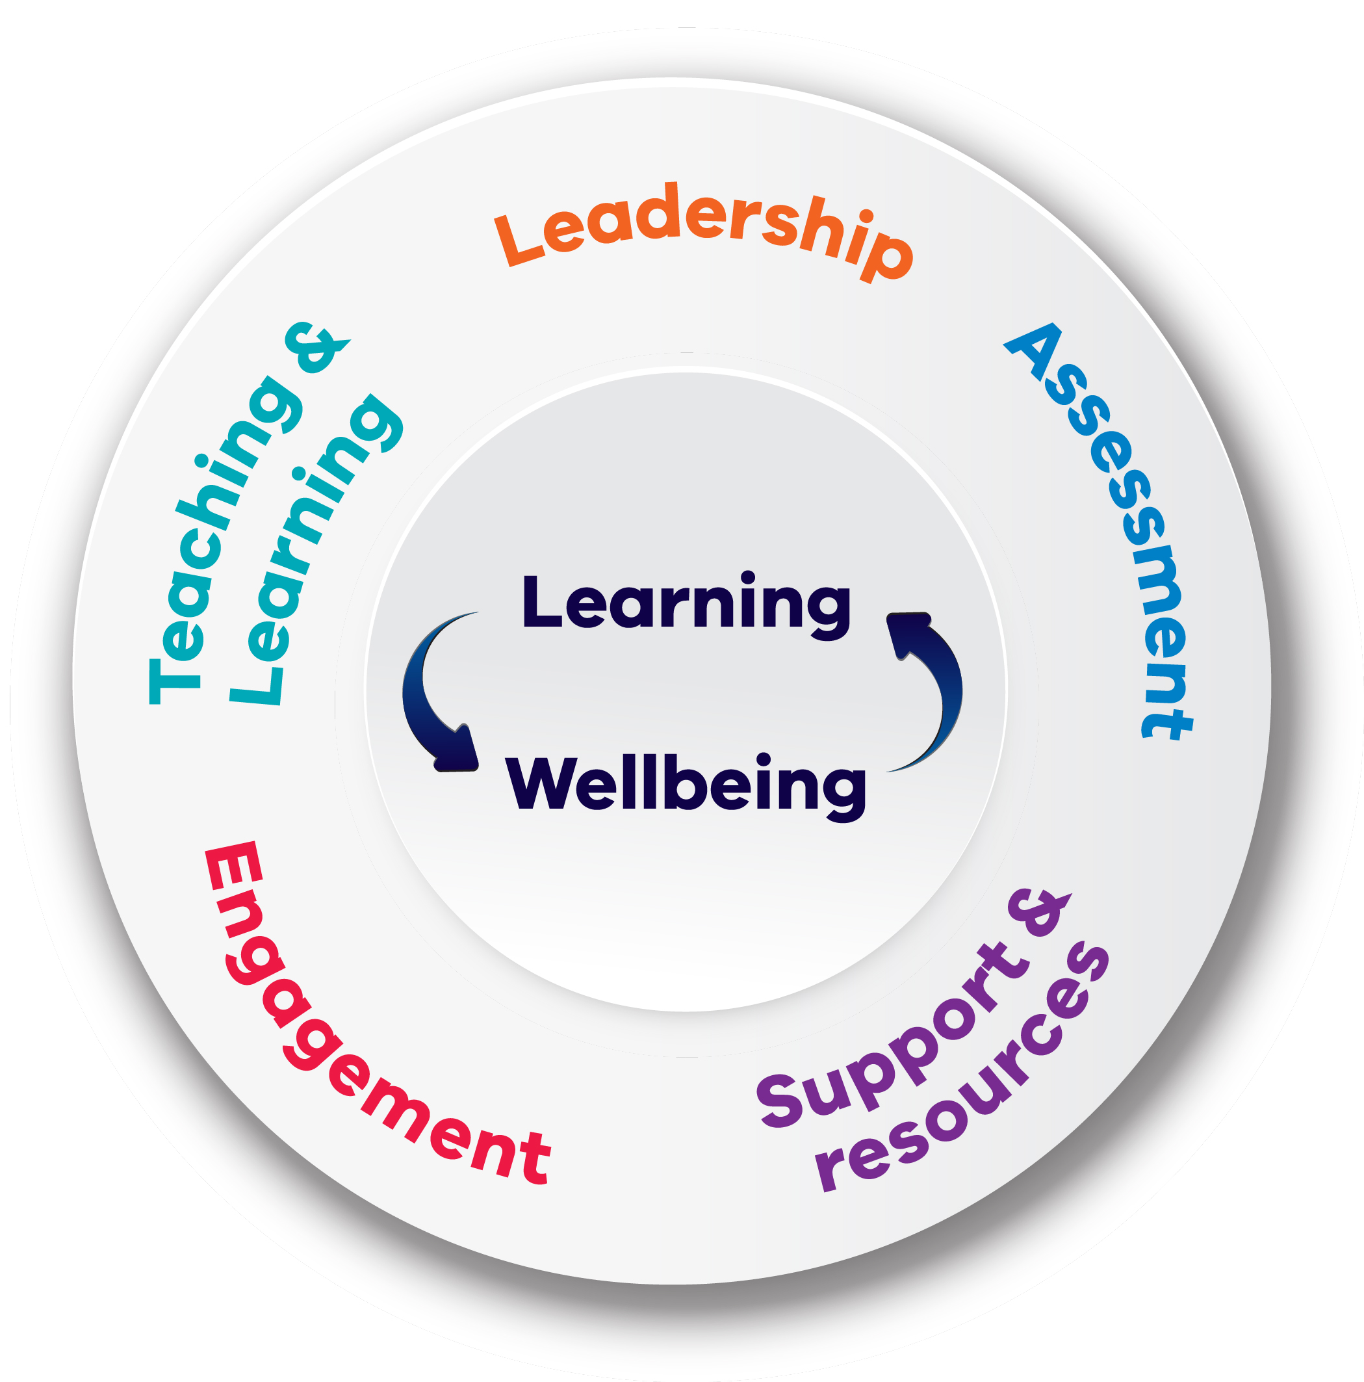
Framework for Improving Student Outcomes (FISO 2.0)

Illustrations of practice and system measures
The Illustrations of practice are examples of effective practice within each dimension. They are used to diagnose areas for improvement and can be used as a benchmark against which to reflect on current practice.

The FISO 2.0 dimensions indicate priority areas of practice that improve students’ learning and wellbeing. Self-evaluation of practice against the dimensions is supported by the illustrations of practice for each dimension, which support schools to look more closely at specific aspects of their practice within each dimension.

LEADERSHIP
DIMENSION
The strategic direction and deployment of resources to create and reflect shared goals and values; high expectations; and a positive, safe and orderly learning environment

Illustrations of practice
- Leaders actively engage students, staff, families/carers, and communities to develop, communicate and consistently demonstrate high expectations for every student’s learning and wellbeing
- Leaders engage student, staff, families/carers, and communities to develop goals aligned with the school’s inclusive and strengths-based vision, values and strategic plan
- Leaders consistently model the shared values and expectations for establishing positive and trusting relationships among and between teachers, students, families/carers and communities
- Leaders accurately assess the school’s current and anticipated resourcing needs for planning, and strategically recruit and induct staff with specific expertise who offer the best fit for school improvement
- Leaders use adaptive expertise to explore challenges and seek to understand issues in context before establishing innovative solutions for school improvement
- Leaders work together to maintain a focus on development, ensuring the learning and wellbeing goals and targets of the strategic plan are linked to the strategies and actions of the AIP
- Students and leaders collaborate to develop strategies to enhance wellbeing and promote safety to reduce violence, bullying and abuse in all online and physical environments
- Students and leaders collaboratively develop and revise whole school policies, plans and structures to ensure a positive, safe and orderly learning environment that promotes inclusion and the wellbeing of staff and students.

Measures
The measures below should be considered alongside the outcome measures and school-level measures.
- Attitudes to School Survey – Managing bullying
- School Staff Survey – Instructional leadership, trust in colleagues, collective efficacy, academic emphasis

LEADERSHIP
DIMENSION
Shared development of a culture of respect and collaboration with positive and supportive relationships between students and staff at the core

Illustrations of practice
- The school improvement team monitors and implements evidence-based strategies and actions to improve student learning and wellbeing in response to needs identified through the improvement cycle
- Leaders develop partnerships with other schools and agencies through engaging or leading and creating networks and/or communities of practice to develop understanding of how similar schools actively support students’ learning and wellbeing
- Leaders actively support and celebrate diversity and inclusion, promote cultural awareness and safety and address discrimination and racism to promote respectful and inclusive attitudes, behaviours and practices
- Middle leaders provide targeted guidance and support to teachers and staff, based on student outcomes and feedback, teaching, engagement and support practices, and contemporary research
- Students’ views, priorities and feedback are heard and responded to by leaders through meaningful interactions, through which students openly share their experiences and leaders authentically support a solution-focused approach to improving outcomes
- Students are actively involved in school improvement planning, and support the design and implementation of inclusive leadership, teaching and learning, assessment, engagement and support programs and practices.

Measures
The measures below should be considered alongside the outcome measures and school-level measures.
- Attitudes to School Survey – Managing bullying
- School Staff Survey – Instructional leadership, trust in colleagues, collective efficacy, academic emphasis

TEACHING AND LEARNING

DIMENSION
Documented teaching and learning program based on the Victorian Curriculum and senior secondary pathways, incorporating extra-curricular programs.

Illustrations of practice
- Teaching and learning programs:
- integrate curriculum capabilities and learning areas
- embed social and emotional learning
- apply high-impact teaching strategies
- use multiple assessment techniques
- are coherent, sequential and developmental programs
- Teachers investigate and understand the learning and wellbeing needs of students by analysing student data to design stimulating teaching and learning programs
- Leaders, teachers and students use student-level data and evidence to regularly evaluate curriculum and extra-curricular programs, including how they meet diverse learning and wellbeing goals and needs
- Students and teachers collaborate to design learning intentions that connect to real world contexts and empowers students to explore issues and take action to solve problems
- Leaders extend and broaden the curriculum experiences of students by encouraging future independence and expertise through networks with industry
- Teachers involve students and their families/carers to develop a shared understanding of the expected outcomes for learning growth, attainment and wellbeing capabilities

Measures
The measures below should be considered alongside the outcome measures and school-level measures.
- Teacher Judgement – learning growth
- Attitudes to School Survey – Stimulated learning
- School Staff Survey – Guaranteed and viable curriculum (secondary), academic emphasis

TEACHING AND LEARNING
DIMENSION
Use of common and subject-specific high impact teaching and learning strategies as part of a shared and responsive teaching and learning model implemented through culturally sensitive, positive and supportive student-staff relationships

Illustrations of practice
- Teachers respond to student learning and wellbeing needs using common and subject-specific high-impact teaching and learning strategies as part of a shared and guaranteed and viable curriculum responsive to their teaching and learning model including where the wellbeing capabilities connect
- Leaders regularly collaborate with teachers to build their capacity in identifying and responding to the learning and wellbeing needs of students through tiered approaches of support
- Teachers differentiate their pedagogy, lesson plans and assessments to ensure learners of all abilities can access the curriculum and engage in stimulating learning experiences that enable them to achieve their learning growth milestones and wellbeing capabilities
- Leaders establish sustainable routines for collaboration and professional development, ensuring classroom observation, interna/external programs, PDPs and the modelling of effective practice and feedback are effectively embedded in the school
- Teachers critically reflect individually and collaboratively to enhance their impact on student wellbeing and learning, using the improvement cycle to ensure their practice is informed by contemporary research and evidence

Measures
The measures below should be considered alongside the outcome measures and school-level measures.
- Teacher Judgement – learning growth
- Attitudes to School Survey – Stimulated learning
- School Staff Survey – Guaranteed and viable curriculum (secondary), academic emphasis

ASSESSMENT
DIMENSION
Systematic use of assessment strategies and measurement practices to obtain and provide feedback on student learning growth, attainment and wellbeing capabilities

Illustrations of practice
- Leaders and teachers have effective systems in place to support ongoing data analysis, which is understood and used by all staff to access and use data at multiple levels of the school effectively and readily
- Teachers effectively design and implement high quality formative and summative assessment techniques to assess students’ knowledge of the curriculum and progress against the achievement standards
- Leaders and teachers regularly measure and moderate student learning and wellbeing data and identify risks to inform tiered and responsive supports
- Staff collaborate to develop a documented assessment plan and implement formalised processes and expectations for assessment and provide structured feedback on student learning and wellbeing
- Teachers’ professional judgement is validated through interrogation of multiple sources of data and evidence by skilled teacher teams, peer observation, moderation and cross-marking
- Teachers partner with students and families/carers to use assessment measurement tools to regularly provide accurate, detailed and targeted guidance to students on their progress toward individual learning and wellbeing goals and progress against the achievement standards
- Students assess their work and solve problems effectively, receiving scaffolding and feedback from teachers to build their skills in monitoring and evaluating their progress

Measures
The measures below should be considered alongside the outcome measures and school-level measures.
- School Staff Survey – Moderation of student assessment, monitoring effectiveness of using data, understand formative assessment, use of student feedback to inform teaching practice

ASSESSMENT
DIMENSION
Systematic use of data and evidence to drive the prioritisation, development, and implementation of actions in schools and classrooms

Illustrations of practice
- Staff use a whole school approach to continuously develop their data literacy and analysis capabilities through targeted engagement in relevant professional development opportunities
- Leaders and teachers adapt their teaching and learning strategies and practice in response to student feedback received as part of student-led conferences
- Teachers work independently and in teams to actively monitor student learning using formative and summative assessment, conducting longitudinal data analysis and engaging with students and their families/carers to plan and adapt teacher practice utilising the improvement cycle
- Staff work independently and in teams to actively monitor student wellbeing through conducting data analysis and engaging with students and their families/carers to identify and embed practices and processes that promote positive wellbeing
- Teachers work together to moderate student assessment, developing a shared understanding of what learning looks like by examining different types and quality of students’ work and comparing these with the achievement standards.
- Leaders and teachers prioritise areas for focus by tracking and monitoring individual students, using high impact assessment practices as part of a tiered approach.

Measures
The measures below should be considered alongside the outcome measures and school-level measures.
- School Staff Survey – Moderation of student assessment, monitoring effectiveness of using data, understand formative assessment, use of student feedback to inform teaching practice

ENGAGEMENT
DIMENSION
Activation of student voice, agency, leadership and learning, including a focus on the self-determination and agency of Koorie students, to strengthen students’ participation and engagement in school

Illustrations of practice
- Leaders communicate the importance of voice, agency and leadership through the school’s vision and values, and establish systems and structures that enhance students’ participation and engagement and foster a sense of connectedness.
- Student leaders have clear roles and responsibilities in the co-design and implementation of wellbeing policies and programs, model inclusive leadership principles and values and represent their school and its students confidently.
- Students participate in regular, meaningful student-led forums that collect and analyse student feedback and perception data and evidence, informing how leaders and teachers make decisions about learning and wellbeing
- Students participate in a range of structured leadership roles that represent the diversity of the school community, which provide them with opportunities to develop a range of skills including communication and decision-making
- Teachers authentically engage with students to design rich, open-ended tasks and lead in the design and implementation of inclusive teaching, learning and wellbeing practices
- Students plan, monitor, evaluate their learning and solve problems independently, supported by critical thinking tools, strategies and processes, feedback and scaffolding appropriate to their specific learning needs

Measures
The measures below should be considered alongside the outcome measures and school-level measures.
- CASES – Proportion of students with less than 20 absent days
- Attitudes to School Survey – Attitudes to attendance, sense of confidence, student voice and agency, school connectedness

ENGAGEMENT
DIMENSION
Strong relationships and active partnerships between schools and families/carers, communities, and organisations to strengthen students’ participation and engagement in school

Illustrations of practice
- Leaders ensure students have at least one ongoing relationship with a teacher, or other school staff member, who provides targeted guidance and support to help them achieve their potential (a ‘significant adult’ for every student)
- Leaders and teachers build collaborative relationships with families/carers and communities to create a shared understanding of how to support students’ participation and engagement, through feedback, raising concerns and shared decision-making.
- The leadership team provides accessible guidance and resources on how families/carers collaborate with teachers, set high expectations, actively engage in their child’s development and support learning and wellbeing
- Leaders and teachers maintain inclusive and sustainable relationships diverse communities and organisation to seek guidance, advice and feedback on how to maintain inclusive services and activities
- Staff establish and sustain culturally respectful partnerships with all students, families/carers and communities by ensuring a shared understanding of cultural norms and protocols
- Leaders and teachers monitor and evaluate attendance and partner with families/carers and the community to implement targeted interventions using a tiered model of support
- Leaders, teachers and students create strong relationships with other schools and agencies through partnerships, networks and communities of practice to enhance student participation and engagement in school.

Measures
The measures below should be considered alongside the outcome measures and school-level measures.
- CASES – Proportion of students with less than 20 absent days
- Attitudes to School Survey – Attitudes to attendance, sense of confidence, student voice and agency, school connectedness.

SUPPORT AND RESOURCES
DIMENSION
Responsive, tiered, culturally appropriate and contextualised approaches and strong relationships to support student learning, wellbeing and inclusion

Illustrations of practice
- Leaders and teachers integrate evidence-based academic, wellbeing, and behaviour supports within a tiered system of support aligned to the school’s strategic plan, vision and values in partnership with the school community
- Leaders actively evaluate, update and make explicit the policies and practices that promote inclusion, positive behaviour and a safe environment to ensure all members of the school community understand and enact them
- Students’ diverse needs are evaluated in a timely, proactive and strategic manner, in collaboration with their families/carers, to ensure the application of tiered supports that respond to the learning and wellbeing needs of every student
- Teachers effectively identify and respectfully respond to the various learning and wellbeing needs of individuals and groups, using a unified multi-tiered system of support
- Leaders ensures students feel safe and develop strong relationships with peers, teachers and staff over transitionary periods by providing targeted opportunities for students to develop their capacity to confidently engage with others and contribute to a safe and inclusive environment.
- Leaders hold regular Student Support Groups to collaborate, focus, and understand vulnerable students’ needs and make regular and reasonable adjustments to education plans to ensure learning and wellbeing goals are realistic and achievable.
- Students are provided opportunities to lead and demonstrate agency in collaboration with teachers and parents/carers to create a shared understanding of how to support and enhance learning and wellbeing in respect to the school’s culture and context.

Measures
The measures below should be considered alongside the outcome measures and school-level measures.
- Attitudes to School Survey – Advocate at school, experience of bullying, managing bullying, respect for diversity

SUPPORT AND RESOURCES
DIMENSION
Effective use of resources and active partnerships with families/carers, specialist providers and community organisations to provide responsive support to students

Illustrations of practice
- Representative community partners are actively involved in school strategic planning to ensure learning and wellbeing is improved and supported in inclusive and culturally appropriate ways
- Leaders work with area multidisciplinary team experts regularly to complete a cohort- specific, inclusive climate assessment to identify opportunities for, and barriers to, inclusion to plan school and classroom level adjustments to enhance the whole school culture
- Leaders establish the school as a hub by providing access and referral pathways to community support services and, where appropriate, having community services on site
- Teachers engage specialist services and community organisations to inform their teaching and learning programs, assessment practices, and implementation of tiered support to ensure access and participation in education and learning for all students
- Leaders and teachers build strong networks to actively promote and connect students and their families/carers to supportive programs and services
- Staff build capacity of the school community by engaging with culturally diverse communities, identifying and establishing partnerships that promote practical application of students’ cultural and civic wellbeing capabilities
- Teachers create strong industry and community connections for students to engage in meaningful future pathway opportunities and support a smooth transition into further education, training, and employment pathways.

Measures
The measures below should be considered alongside the outcome measures and school-level measures.
- Attitudes to School Survey – Advocate at school, experience of bullying, managing bullying, respect for diversity.

