Student Travel Assistance Portal (STAP)

Quick Reference Guide for School Bus Operators
This guide provides step-by-step instructions on how to:
- Register a new account
- Login to your account
- Update your account details
- View a bus route
- View a timetable
- View and export bus roll reports
STAP website: https://studenttravelassistance.educationapps.vic.gov.au

Register a new account
Go to the STAP website.
- Click on Register
- Click I am a Bus Operator
- Click Continue
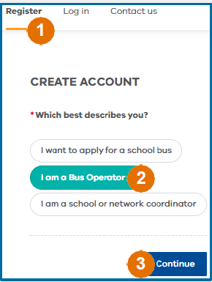
- Complete your details
- Enter your manager’s name

- Click Submit
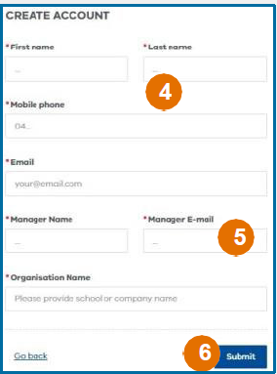
- Your manager will be sent an email to approve your request
- If approved, your account will be activated and you will receive an email with your log-in details and a temporary password.

Login to your account
- Click Log in
- Enter the email address you registered with and password. A verification code will be sent to your email address
- If you have forgotten your password, click Forgot Password
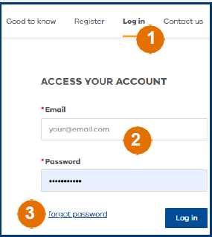
- Enter the verification code
- Click Verify Code.
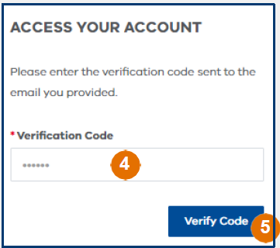

Update your account details
- Click on My Account
- Click Edit Details
- Make changes to your email, address, phone number or to reset your password.
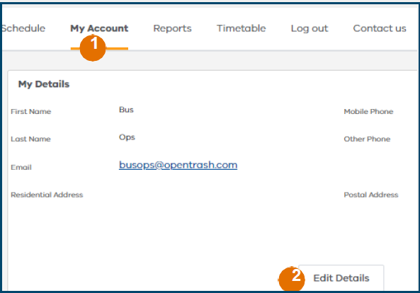

View a bus route
- Click Schedule
- Search by the Contract Id or Contract Name
- Sort information by clicking a subject heading
- Click on the arrow to see traveller details
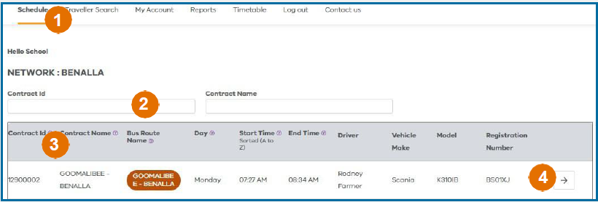
- View the pick-up and drop-off passenger list for each stop
- View the map with stops
- Click on the blue link to show the specific stop location
- The bus route can be downloaded or printed.
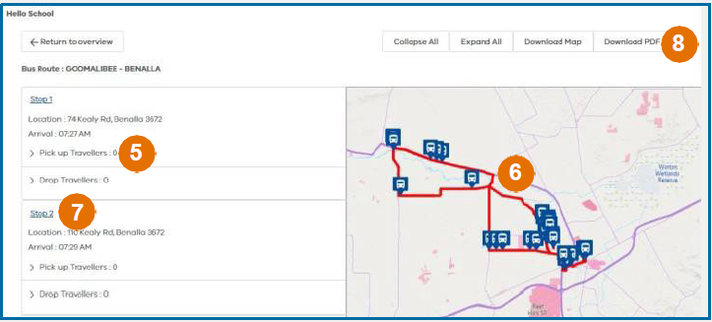

View a timetable
1. Click Timetable
2. Select the network and route details
3. Click Search
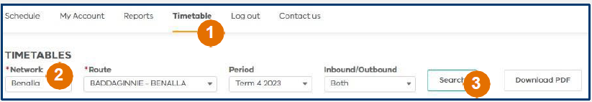
- A map and list of bus stops will be displayed
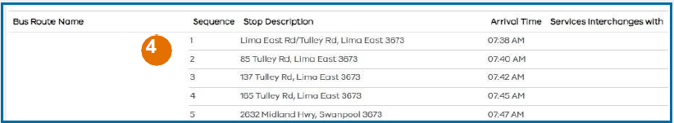
5. This map and list of stops can be downloaded and printed.

View and export bus roll reports
- Click Reports
- Select a report to view
- Reports can be exported to Excel
